SAFETY DATA SHEET
Compiled in accordance with REACH Regulation (EC) No 1907/2006, as amended by UK REACH Regulations SI 2019/758

SECTION 1: Identification of the Substance/Mixture and of the Company/Undertaking

1.1. Product Identifier
Zoflora Disinfectant Mist Raspberry & Juniper Berry

1.2. Relevant identified uses of substance or mixture and uses advised against
Household hygienic cleaning product

1.3. Details of supplier of the safety data sheet
Supplier name: Thornton & Ross
Supplier address: Linthwaite, Huddersfield, HD7 5QH
Telephone: +44 (0) 1484 842 217
Fax: +44 (0) 1484 847 301
Email: sds@thorntonross.com

1.4. Emergency telephone number
Telephone: +44 (0) 1484 848 164
Available: Out of working hours

SECTION 2: Hazards Identification

2.1. Classification of the substance or mixture
According to Regulation (EC) No. 1272/2008 (GB-CLP) the mixture is classified as Aerosol Category 1, Eye Irritant Category 2.

2.2. Label elements
Hazard Pictograms: 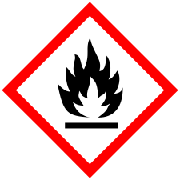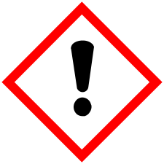

Signal word: Danger

Hazard statements: H222 Extremely flammable aerosol.
H229 Pressurised container: may burst if heated.
H319 Causes serious eye irritation.

Precautionary statements: P210 Keep away from heat, hot surfaces, sparks, open flames and other ignition sources. No smoking.
P211 Do not spray on an open flame or other ignition source.
P251 Do not pierce or burn, even after use.
P264 Wash contaminated skin thoroughly after handling.
P280 Wear protective gloves/ protective clothing/ eye protection/ face protection.
P305+P351+P338 IF IN EYES: Rinse cautiously with water for several minutes. Remove contact lenses, if present and easy to do. Continue rinsing.
P337+P313 If eye irritation persists: Get medical advice/ attention.
P410+P412 Protect from sunlight. Do not expose to temperatures exceeding 50°C/122°F.

2.3. Other hazards
None known

SECTION 3: Composition/Information on Ingredients

3.2. Mixtures
Hazardous Ingredient(s) | %w/w | CAS no  EC/List no  REACH reg. no | Hazard Classification | H Statements
Ethanol | 74.0% | 64-17-5  200-578-6 | Flam. Liq. 2  Eye Irr. 2 | 225  319
Petroleum Gases, Liquefied | 10-30% | 68476-85-7  270-704-2 | Flam. Gas 1  Press. Gas (Liq.) | 220  280
Sodium Nitrite | <1% | 7632-00-0  231-555-9  M Factor (Acute) = 1 | Ox. Sol. 3  Acute Tox. 3  Aquatic Acute 1 | 272  301  400

*Full text of H-Phrases can be found in Section 16.3

SECTION 4: First Aid Measures

4.1. Description of first aid measures
If inhaled: Remove from exposure and get fresh air. If symptoms develop get medical attention.
If on skin: Wash skin thoroughly with water and soap. If irritation persists, seek medical advice.

If in eyes: Rinse with plenty of water for at least 10 minutes. If irritation persists, seek medical advice.

If swallowed: Wash out mouth with water. If symptoms develop seek medical attention.

Other first aid advice: None Known

4.2. Most important symptoms and effects, both acute and delayed
If inhaled: None Known

If on skin: None Known

If in eyes: None Known

If swallowed: None Known

4.3. Indication of any immediate medical attention and special treatment needed
Medical treatment: If unsure about any symptoms contact a doctor or emergency service.

SECTION 5: Firefighting Measures

5.1. Extinguishing media
Suitable extinguishing media: Foam, carbon dioxide or powder extinguishers.

Unsuitable extinguishing media: Do not use water jet.

5.2. Special hazards arising from the substance or mixture
Pressurised container: may burst if heated

5.3. Advice for firefighters
Wear self-contained breathing apparatus and protective clothing. Containers close to the fire should be removed or cooled with water. Use water to keep exposed containers cool and disperse vapours.

SECTION 6: Accidental Release Measures

6.1. Personal precautions, protective equipment and emergency procedures
Non-emergency personnel: Wear appropriate protective clothing, no smoking, sparks, flames or other sources of ignition near spillage

Emergency personnel: Wear appropriate protective clothing, no smoking, sparks, flames or other sources of ignition near spillage

6.2. Environmental precautions
Prevent material entering drains and watercourses. Advise local authorities if spillage has entered watercourses and sewer.

6.3. Methods and material for containment and cleaning up
Eliminate all sources of ignition. Provide adequate ventilation. Absorb onto inert material and transfer to suitable containers for disposal by a licensed waste contractor.

6.4. Reference to other sections
See Section 8 for protective equipment requirements.

SECTION 7: Handling and Storage

7.1. Precautions for safe handling
Handling: Avoid contact with skin and eyes. Keep away from heat, hot surfaces, sparks, open flames and other ignition sources. No smoking

Hygiene: Do not eat, drink or smoke while using this product. Wash hands thoroughly after use.

7.2. Conditions for safe storage, including any incompatibilities
Store below 25°C, store away from light and heat.

7.3. Specific end use(s)
Household hygienic cleaning product

SECTION 8: Exposure Controls/Personal Protection

8.1. Control parameters
Ethanol: Long-term exposure limit (8-hour TWA): WEL 1000 ppm/1920 mg/m³

Petroleum Gases, Liquefied: Long-term exposure limit (8-hour TWA): WEL 1000 ppm/1750 mg/m³
Short-term exposure limit (15-minute): WEL 1250 ppm/2180mg/m³
WEL = Workplace Exposure Limit

8.2. Exposure controls
Engineering controls: Ensure adequate ventilation.

Eye/Face protection: Safety glasses. Use equipment for eye protection tested and approved under appropriate government standards EN 166(EU).

Hand protection: Not required

Skin Protection: Overalls must be worn when handling large quantities

Other protection: Not required

Respiratory protection: Not required

Thermal hazards: None known

Environmental controls: Prevent further leakage or spillage if safe to do so. Do not let product enter drains. Discharge into the environment must be avoided. See Section 6.2

SECTION 9: Physical and Chemical Properties

9.1. Information on basic chemical and physical properties
Appearance: Aerosol

Odour: Characteristic

Odour threshold: Not determined

PH: Not determined

Melting/freezing point: Not determined

Initial boiling point: Not determined

Boiling range: Not determined

Flash point: Not determined

Evaporation rate: Not determined

Flammability: Not determined

Decomposition temperature: Not determined

Viscosity : Not determined

Upper explosive limit: Not determined

Lower explosive limit: Not determined

Vapour pressure: Not determined

Vapour density (Air=1): Not determined

Relative density: Not determined

Solubility: Not determined

Partition coefficient: Not determined

Auto ignition temperature: Not determined

Oxidizing properties: Not determined

Explosive properties: Not determined

9.2. Other information
Not available

SECTION 10: Stability and Reactivity

10.1. Reactivity
Stable at normal ambient temperatures.

10.2. Chemical stability
Stable at normal ambient temperatures

10.3. Possibility of hazardous reactions
None known

10.4. Conditions to avoid
Avoid exposing aerosol containers to high temperatures or direct sunlight.

10.5. Incompatible materials
None known

10.6. Hazardous decomposition products
None known

SECTION 11: Toxicological Information

11.1. Information on toxicological effects
ATE oral (mg/kg): 100,000.0

Skin corrosion/irritation: May irritate skin

Serious eye damage/irritation: Causes serious eye irritation

Respiratory or skin sensitisation: Some perfumes may cause sensitisation by skin contact

Germ cell mutagenicity: Data not available

Carcinogenicity: Data not available

Reproductive toxicity: Data not available

STOT-single exposure: Data not available

STOT-repeated exposure: Data not available

Aspiration hazard: Data not available

11.2. Other information
Not applicable

SECTION 12: Ecological Information

12.1. Toxicity
Data not available

12.2. Persistence and degradability
Data not available

12.3. Bioaccumulate potential
Data not available

12.4. Mobility in soil
Data not available

12.5. Results of PBT and vPvB assessment
Data not available

12.6. Other adverse effects
Not applicable

SECTION 13: Disposal Considerations

13.1. Waste treatment methods
Dispose of waste, residues or used containers in accordance with local authority requirements.

SECTION 14: Transport Information

14.1. UN number
UN No. (ADR/RID) 1950
UN No. (IMDG) 1950
UN No. (ICAO) 1950
UN No. (AND) 1950

14.2. UN proper shipping name
(ADR/RID) AEROSOLS
(IMDG) AEROSOLS
(ICAO) AEROSOLS
(ADN) AEROSOLS

14.3. Transport hazard class (es)
ADR/RID class 2.1
ADR/RID classification code 5F
ADR/RID label 2.1
IMDG class 2.1
ICAO class/division 2.1
ADN class 2.1
Transport labels
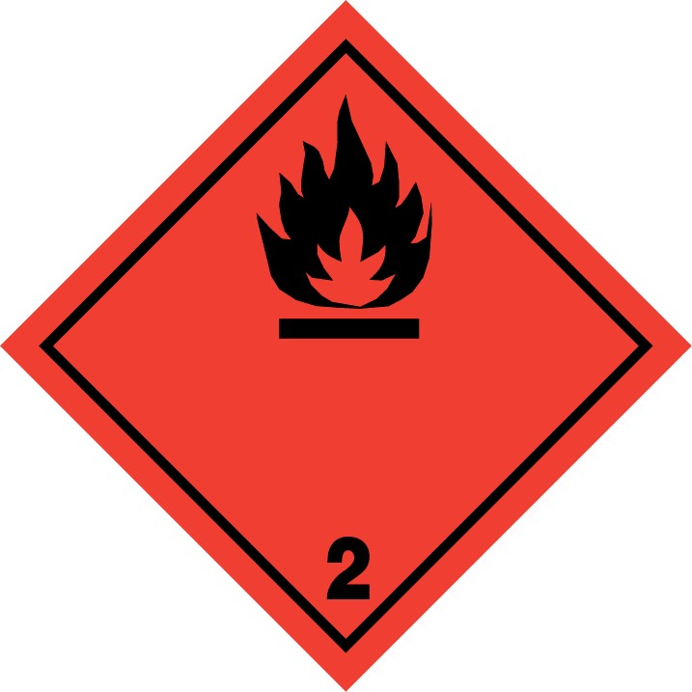

14.4. Packing group
N/A

14.5. Environmental hazards
N/A

14.6. Special precautions for user
EmS F-D, S-U
ADR transport category 2
Tunnel restriction code (D)

14.7. Transport in bulk according to Annex II of MARPOL73/78 and the IBC code
N/A

Additional Information:
N/A

SECTION 15: Regulatory Information

15.1. Safety, health and environmental regulations/legislation specific for the substance or mixture
Not regulated by specific legislation

15.2. Chemical safety assessment
Not available

SECTION 16: Other Information

16.1. Reason for change
New Product

16.2. Sources of information
Ingredient safety data sheet(s), C&L Inventory and REACH Dossiers.

16.3. Full text of H phrases from Section 3
H220 Extremely flammable gas.
H222 Extremely flammable aerosol.
H225 Highly flammable liquid and vapour.
H229 Pressurised container: may burst if heated.
H272 May intensify fire; oxidiser.
H280 Contains gas under pressure; may explode if heated.
H301 Toxic if swallowed.
H319 Causes serious eye irritation.
H400 Very toxic to aquatic life.

16.4. Method of evaluation
Hazards for mixture calculated in accordance with Regulation (EC) No. 1272/2008 (GB-CLP) using the information provided for constituents (ingredients).

